***Assignment Name****:* ***Lab6:*** *(****Loops and Input Control)***

***Due date:******10/19/2022, by 11:00 am.***

***Grade for assignment: 30*** *points*

***Purpose:*** *Obtain experience using while loops and working with accumulators and counters. Also become aware of the need for input control to help secure software applications. Assignment accomplishes course learning objective “using basic control structures”. Assignment also provides preparation for COSC236 course, and enhances skills needed in Information Technology (IT) and Computer Science industries.*

***Skills:*** *Purpose of assignment is to help you practice the following skills.*

*-Ability to use accumulators and counters*

*-Ability to effectively use loops in computer programs*

*-Ability to use loops for input control*

***Knowledge:*** *Become familiar with when to use different control structures.*

***\*\*\*\*\*\*\*\*\*\*\*\*\*\*\*\*\*\*\*\*\*\*\*\*\*\*\*\*\*\*\*\*\*\*\*\*\*\*\*\*\*\*\*\*\*\*\*\*\*\*\*\*\*\*\*\*\*\*\*\*\*\*\*\*\*\*\*\*\*\*\*\*\*\*\*\****

***Place your Name(s) below:***

***Pairs work:*** *Please work in pairs.* ***One student in team should submit work****. Put* ***your first and last name on the assignment*** *and* ***your partner’s first and last name on the*** *assignment*

***Note(s):***

1. *All programs should be completed within the Visual Studio Code environment. There are guides in blackboard to start you off with Visual Studio Code.*

***Partner 1: Name*** Blessing Abumere

***role (did the typing or read and review) _____________________________***

***Partner 2: Name ______________________________________________***

***role (did the typing or read and review)______________________________***

***Please note if one partner did not work on all problems.***

***Submission instructions:*** *All submissions will be done using blackboard.* ***Answers are to be submitted in a Microsoft word document.***

***Task****:*

***Examples:*** *Refer to your notes from class, the Loops (Part1) PowerPoint, in class exercises and any available videos (all located in Blackboard).*

***Part1 (15 Points):***

1. *Type in the following program. Add a comment at the top to include your name(s) and the date.*

#include <iostream>

using namespace std;

int main()

{

int num;

cout << endl << "Enter numbers, 999 to quit" << endl; //1.Start

cin >> num; //1.Start

while (num != 999) //2.Test

{

cout << "Number entered is: " << num << endl; //3.Action

cout << "Enter numbers, 999 to quit" << endl; //4.Restart

cin >> num; //4.Restart

}

return 0;

}

*-Compile and Run with different values.*

*a) Add the steps to total the number entered; total number entered should display once after loop ends.*

*b) Add the steps to count how many numbers entered; total count should display once after loop ends.*

*c) Test with values you know the answer to. (At least three test)*

*d)* ***SUBMIT your corrected code, and sample of output (Below):***

/*

    Blessing Abumere

    10/12/2022

    COSC 175

*/

#include <iostream>

using namespace std;

int main()

{

    int num;

    int sum=0; // sum of inputs

    int count = 0 ; //total times ran

    cout << endl << "Enter numbers, 999 to quit" << endl; //1.Start

    cin >> num; //1.Start

    while (num != 999) //2.Test

    {

        sum += num;

        count++;

        cout << "\nNumber entered is: " << num << endl; //3.Action

        cout << "Enter numbers, 999 to quit" << endl; //4.Restart

        cin >> num; //4.Restart

    }

    cout << "\nThe Total Of All Numbers Entered Was: " << sum << endl;

    cout << "The Total Count Was: " << count;

    return 0;

}

***Part2 (15 points):***

1. *Copy and paste the link below into a Google web browser and complete the Security Injection, for Input validation.*

[*http://cis1.towson.edu/~cyber4all/modules/nanomodules/Input_Validation-CS0_C++.html*](http://cis1.towson.edu/~cyber4all/modules/nanomodules/Input_Validation-CS0_C++.html)

1. ***SUBMIT copy of Security Injection certificate(s) (Below):***

***\*\*\*\*\*\*\*\*\*\*\*\*\*\*\*\*\*\*\*\*\*\*\*\*\*\*\*\*\*\*\*\*\*\*\*\*\*\*\*\*\*\*\*\*\*\*\*\*\*\*\*\*\*\*\*\*\*\*\*\*\*\*\*\*\*\*\*\*\*\*\*\*\*\*\*\*\****

***Criteria for Success****:*

***a****) Be sure to submit your code and output above for each question;* ***Submission of Code and output is required****. (Note: use screen shots or copy and paste).*

*For example if the assignment was to write a program that displays “Hello World”*

*Your* ***code*** *would be as follows:*

*//Lab1 answer COSC175002*

*#include <iostream>*

*using namespace std;*

*int main()*

*{*

*cout << "Hello, world" << endl;*

*system("pause");*

*} // end of main*

*Your* ***output*** *would be as follows:*

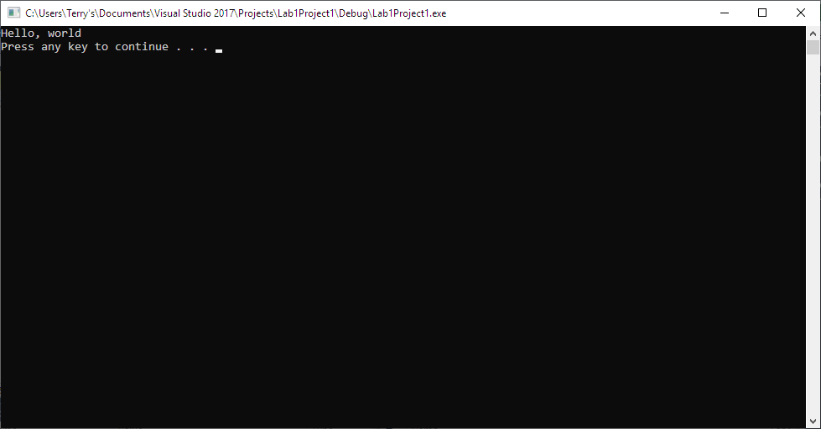

*Note: To avoid additional point deductions; remember to submit both code and output.*

*>>>*

***b)*** *Be sure to show completion of Security Injections by providing Screen shots of (or copy and paste) your Security Injection completion* ***Certificate*** *above****. Do not email me your certificate.***

***c) Late policy:*** *Late submissions will receive a zero grade. Get help during the week so that you can submit on time.*